Hitchkicker’s guide to cinema

Ideation

Project idea
The Idea is to restart from the Hitchhickers’ guide to cinema resulted from the previous course about bootstrap and convert it to be a react app. The main goal in doing so is to redefine the search result page as a single page app.
For further info about the original projects, features and goals, please refer to the doc related to the previous steps of the project (related to Bootstrap course) available in:
https://bitbucket.org/sterte/h2gc/src/master/doc/Course%201%20-%20Bootstrap/

The website resulting from the previous Bootstrap course is available at:
http://sterte.rf.gd/h2gc/

Features
Currently the search result page is designed to present a short result list and a link to IMDb for the complete results (see image below), the main feature to achieve moving to react is to redefine such page as a single page app continuously scrolling and loading search results.
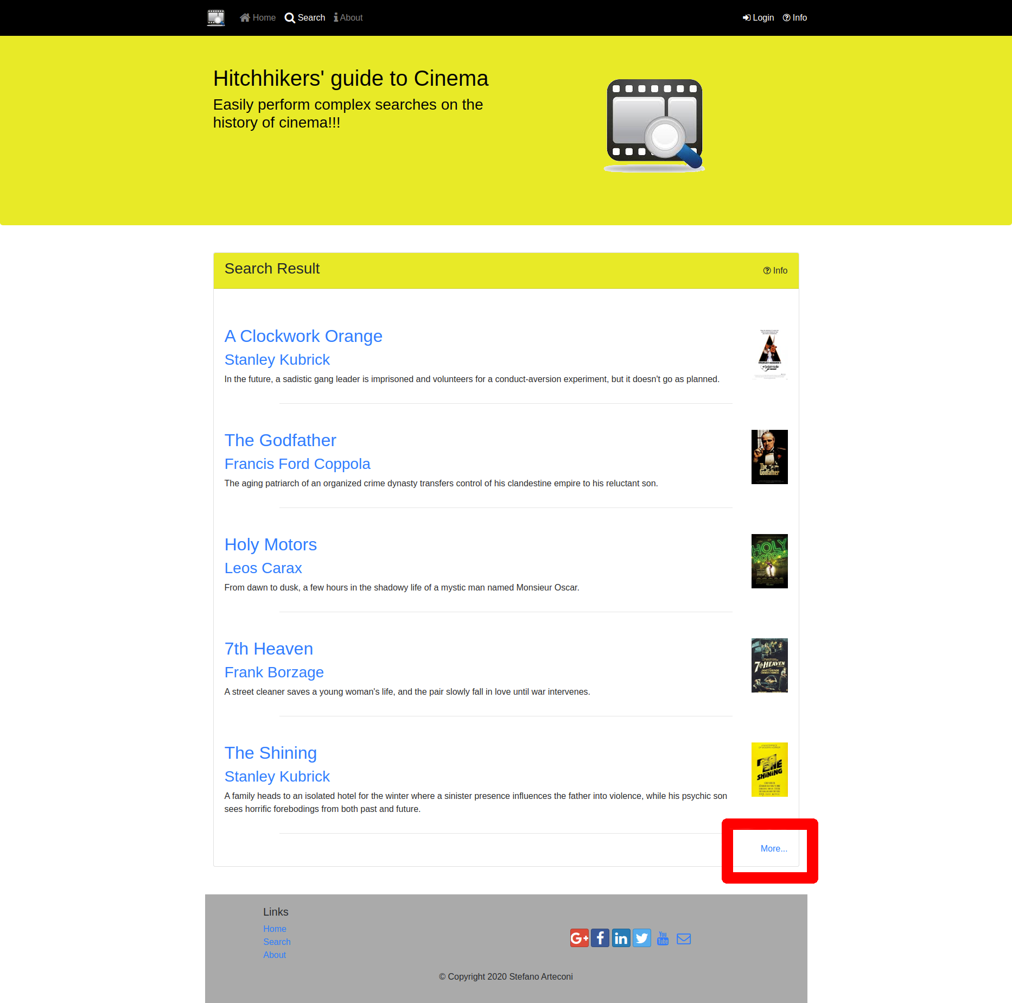

Market Survey
Market survey has already been performed in the previous phase of the project (Bootstrap course), please refer to Bootstrap course ideation doc, available at:
https://bitbucket.org/sterte/h2gc/src/master/doc/Course%201%20-%20Bootstrap/Hitchickers%20guide%20to%20cinema%20-%20Ideation.pdf

References
References have already been performed in the previous phase of the project (Bootstrap course), please refer to Bootstrap course ideation doc. available at:
https://bitbucket.org/sterte/h2gc/src/master/doc/Course%201%20-%20Bootstrap/Hitchickers%20guide%20to%20cinema%20-%20Ideation.pdf

